**STAFF PROFILE**

**BIO-DATA**

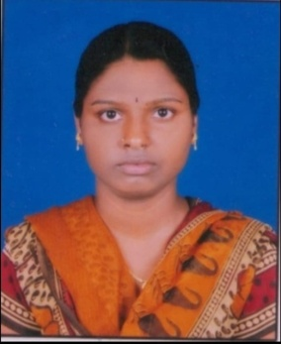

**N.SHIREESHA**

**D/o N. RAJABOGI**

**Assistant professor Telugu , TTWRDC(M) BOATH.**

**Contact No: 9833453743**

Email*: shirishanarmula@gmail.com*

**Academic Qualifications:**

|  |  |  |  |
| --- | --- | --- | --- |
| **Academic** | **Institution** | **% of Marks** | **Year of passing** |
| Ph.D. in Telugu | Telangana University | Pursuing | |
| IMA | Hyderabad Central University | 78 | 2013 |
| IMA | Hyderabad Central University | 78 | 2016 |
| Intermediate (PDC) | SLNSA | 77 | 2010 |
| S.S.C | ZPHS | 72 | 2008 |

**Teaching experience:**

* Working as Assistant Professor in Telugu at TTWRDC(M), Boath at Adilabad, Telangana State, since 11th August 2019.

**Additional Qualifications:**

* **Qualified TS-SET in the year 2018.**
* **Qualified UGC -NET in the year 2018.**

**Awards:**

Received vangoori chittenraju foundation jatiya yuvasahiti sammelanam award.

**List of Publications:**

* Published poem .Book titled jatiya yuva sahithi sammalanam NAVARASANARI MANI titled as poem.(Kavitha).

**Personal Profile:**

Name : N.Shireesha

Father’s Name : N.Rajabogi

Date of Birth : 13/06/1992

Nationality : Indian

Religion : Hindu

Marital Status : Married

Languages Known : Telugu and Hindi.

PERSONAL DETAILS

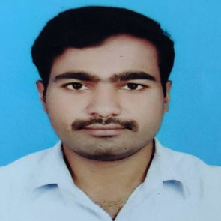

|  |  |
| --- | --- |
| NAME | **Dr. GANDRA MAHESH** |
| FATHER NAME | GANDRA MALLAIAH |
| MOTHER NAME | GANDRA RADHAMMA |
| DESIGNATION | Degree Lecturer in Telugu |
| WORKING INSTITUTION | TTWRDC (M) BOATH @ ADILABAD |
| INSTITUTION TYPE | TRIBAL WELFARE |
| GENDER | MALE |
| RELIGION | HINDU |
| CATEGORY / CASTE | BC |
| SUB – CASTE | MUNNURU KAPU |
| DATE OF BIRTH | 08/07/1991 |
| DATE OF JOINING | 06/09/2017 |
| BLOOD GROUP | B+ ve |

**ADDRESS: (PERMANENT ADDRESS)**

|  |  |
| --- | --- |
| H.NO | 5-50/A/9/11 |
| STREET / VILLAGE | THUNGUR |
| LAND MARK | THUNGUR |
| MANDAL | BEERPUR |
| DISTRICT | JAGTIAL |
| STATE | TELANGANA |
| COUNTRY | INDIA |
| PIN CODE | 505454 |

**CANTACT INFO**

|  |  |
| --- | --- |
| EMAIL | [gandra.mahi@gmail.com](mailto:gandra.mahi@gmail.com) |
| MOBILE NUMBER | +91 9989872717 |

**QUALIFICATION DETAILS**

|  |  |  |  |  |  |  |  |
| --- | --- | --- | --- | --- | --- | --- | --- |
| **Qualification** | **Year of Pass** | **Hall Ticket Number** | **Maximum Marks** | **Secured Marks** | **Percentage** | **Institution/ University** | **Institution Address** |
| **SSC** | 2005-06 | 1017580 | 600 | 475 | 79.1% | ZPHS | THUNGUR, BEERPUR, JAGTIAL Dist. |
| **INTER** | 2006-08 | 047072021 | 1000 | 695 | 69.5% | SLNSA KALASHALA | DHARMAPURI, JAGTIAL Dist. |
| **GRADUATION DEGREE** | 2008-11 | 047093008 | 1600 | 1224 | 76.5% | SLNSA KALASHALA | DHARMAPURI, JAGTIAL Dist. |
| **POST GRADUATION DEGREE** | 2011-13 | 11HTMA25 | 10.00 | 9.17 | 87.63% | UNIVERSITY OF HYDERABAD | HYDERABAD |
| **M.Phil** | 2013-14 | 13HT | 10.00 | 8.75 | 83.75% | UNIVERSITY OF HYDERABAD | HYDERABAD |
| **Ph.D** | 2014-22 | 14HTPH03 | KARIMNAGAR ZILLA KATHA SAHITYAM VASTU, SHILPA ADHYAYANAM (1991-2010) | | | UNIVERSITY OF HYDERABAD | HYDERABAD |

**ADDITIONAL QUALIFICATIONS**

|  |  |  |  |  |  |  |  |
| --- | --- | --- | --- | --- | --- | --- | --- |
| SET (STATE ELIGIBILITY TEST) | 2012 JULY | 112300539 | QUALIFIED | | GOVERNMENT OF ANDHRAPRADESH | | |
| UGC NET | 2013 JUNE | 46270052 | QUALIFIED | | UNIVERSITY GRANTS COMMISSION,  NEW DELHI. | | |
| UGC NET & JRF | 2013 DEC | 46270009 | QUALIFIED UGC – NET for JUNIOR RESEARCH FELLOWSHIP | | UNIVERSITY GRANTS COMMISSION,  NEW DELHI | | |
| TPT (TELUGU PANDIT TRAINING) | 2014 | 1412202037 | 1000 | 662 | 66.2% | OFFICE OF THE DIRECTOR FOR GOVERNMENT EXAMINATIONS, TELANGANA | HYDERABAD |
| M.A SANSKRIT | 2019 | 50321617002 | 800 | 403 | 50.3% | POTTI SRIRAMULU TELUGU UNIVERSITY | HYDERABAD |

**TEACHING EXPERIENCE:**

* Working as Assistant Professor in Commerce at TTWRDC(M), Boath at Adilabad, Telangana State, since 06th September 2017.

**AWARDS:**

* “ALISHETTI PRABHAKAR SMARAKA PURASKAARAM” Award Received from Kala Samithi Jagitial on 12th January 2022.